

**RAMNIRANJAN JHUNJHUNWALA COLLEGE**

**GHATKOPAR (W), MUMBAI - 400 086**

**DEPARTMENT OF INFORMATION TECHNOLOGY**

**2021 - 2022**

**M.Sc.( I.T.) SEM II**

**Project Documentation**

**Name:Manan Sharma**

**Roll No.: 3**



**CERTIFICATE**

This is to certify that Mr~~/Miss/Mrs~~ **Manan Sharma** with **Seat No:3** has successfully completed the mini-project of second semesterduring the academic year 2021 – 2022 complying with the requirements of RAMNIRANJAN JHUNJHUNWALA COLLEGE OF ARTS, SCIENCE AND COMMERCE, for the course of M.Sc. (IT) Semester -I.

_________________________________ 25 th Feb 2021

Internal Examiner Date

_________________________________ ________________

Head Of Department College Seal External Examiner

**Page of Contents**

**Abstract**

1. **Introduction**
2. **Flow of the algorithm**
3. **Data Flow Of Proposed System**
4. **Software Details**
5. **Implementation Word Details**
6. **Source Code commands**
7. **Input/Output screenshots**
8. **Cocnlusion**
9. **Thank You**

**Abstract**

As we know Python is an emerging language so it becomes easy to write a script for Face Detection in Python. The instructions for the Detection can be handled as per the requirement of user. Open CV is the library used in detecting faces. It is commonly used in image processing and performing computer vision tasks. It is an open-source library that can be used to perform tasks like face detection, objection tracking, landmark detection, and much more. It got easier to detect faces , smiles,eyes without typing any word. In the current scenario, advancement in technologies are such that they can perform any task with same effectiveness or can say more effectively than us. By making this project, I realized that the concept of Image Processing in Imagery field is decreasing human effort and saving time.

Functionalities of this project include:

* It can take image as input (upload an image).
* It takes the edges and apply various filters on the edges.
* It can make the image grayscale (black and white) .
* It can Increase or decrease the Contrast .
* It can increase or decrease the brightnesss of the image.
* It can blur the image for according to your need.
* It can detect Faces using face using Harcascadefrontalface.xml .
* It can detect smiles using Harcascadesmile.xml .
* It can detect eyes using Harcascadeeyes.xml .
* It can cartoonize the image.
* It can cannize the image.
* It has a beautiful UI using streamlitt.

**1.Introduction**

Face detection is a technique that identifies or locates human faces in digital images. A typical example of face detection occurs when we take photographs through our smartphones, and it instantly detects faces in the picture. Face detection is different from Face recognition. Face detection detects merely the presence of faces in an image while facial recognition involves identifying whose face it is. In this article, we shall only be dealing with the former.

Face detection is performed by using classifiers. A classifier is essentially an algorithm that decides whether a given image is positive(face) or negative(not a face). A classifier needs to be trained on thousands of images with and without faces. Fortunately, OpenCV already has two pre-trained face detection classifiers, which can readily be used in a program. The two classifiers are:

* Haar Classifier and
* Local Binary Pattern([LBP](https://en.wikipedia.org/wiki/Local_binary_patterns)) classifier.

**We Have only used Haar Classifier It is as follows**

[Haar-like features](https://en.wikipedia.org/wiki/Haar-like_feature) are digital image features used in object recognition. They owe their name to their intuitive similarity with [Haar wavelets](https://en.wikipedia.org/wiki/Haar_wavelet" \o "Haar wavelet) and were used in the first real-time face detector. Paul Viola and Michael Jones in their paper titled ["Rapid Object Detection using a Boosted Cascade of Simple Features"](http://wearables.cc.gatech.edu/paper_of_week/viola01rapid.pdf) used the idea of Haar-feature classifier based on the Haar wavelets. This classifier is widely used for tasks like face detection in computer vision industry.

Haar cascade classifier employs a machine learning approach for visual object detection which is capable of processing images extremely rapidly and achieving high detection rates. This can be attributed to three main [reasons](http://wearables.cc.gatech.edu/paper_of_week/viola01rapid.pdf):

* Haar classifier employs *'Integral Image'* concept which allows the features used by the detector to be computed very quickly.
* The learning algorithm is based on *[AdaBoost](https://en.wikipedia.org/wiki/AdaBoost)*. It selects a small number of important features from a large set and gives highly efficient classifiers.
* More complex classifiers are combined to form a '*cascade*' which discard any non-face regions in an image, thereby spending more computation on promising object-like regions.

**2.The Flow of how Haar classifier algorithm works**

**1. 'Haar features' extraction**

After the tremendous amount of training data (in the form of images) is fed into the system, the classifier begins by extracting Haar features from each image. Haar Features are kind of convolution kernels which primarily detect whether a suitable feature is present on an image or not. Some examples of Haar features are mentioned below:

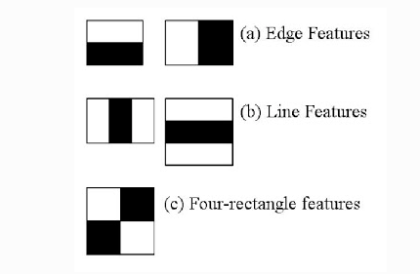  
[source](https://www.cs.cmu.edu/~efros/courses/LBMV07/Papers/viola-cvpr-01.pdf)

These Haar Features are like windows and are placed upon images to compute a single feature. The feature is essentially a single value obtained by subtracting the sum of the pixels under the white region and that under the black. The process can be easily visualized in the example below.

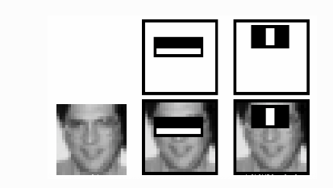

For demonstration purpose, let's say we are only extracting two features, hence we have only two windows here. The first feature relies on the point that the eye region is darker than the adjacent cheeks and nose region. The second feature focuses on the fact that eyes are kind of darker as compared to the bridge of the nose. Thus, when the feature window moves over the eyes, it will calculate a single value. This value will then be compared to some threshold and if it passes that it will conclude that there is an edge here or some positive feature.

**2. 'Integral Images' concept**

The algorithm proposed by Viola Jones uses a 24X24 base window size, and that would result in more than 180,000 features being calculated in this window. Imagine calculating the pixel difference for all the features? The solution devised for this computationally intensive process is to go for the **Integral Image** concept. The integral image means that to find the sum of all pixels under any rectangle, we simply need the four corner values.

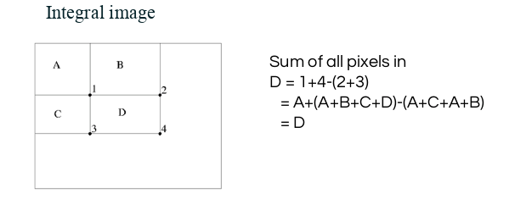  
[source](https://www.cs.cmu.edu/~efros/courses/LBMV07/Papers/viola-cvpr-01.pdf)

This means, to calculate the sum of pixels in any feature window, we do not need to sum them up individually. All we need is to calculate the integral image using the 4 corner values. The example below will make the process transparent.

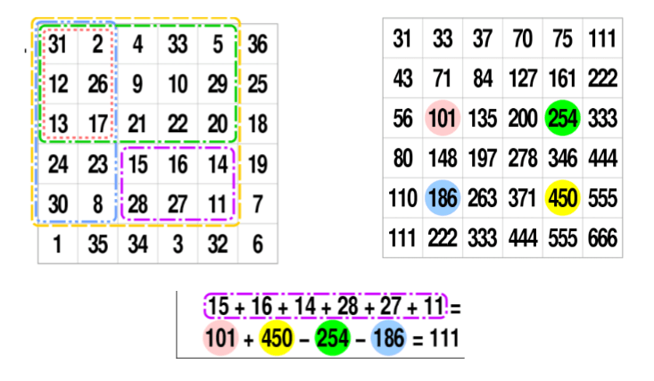  
[source](https://en.wikipedia.org/wiki/Summed-area_table)

**3. 'Adaboost' : to improve classifier accuracy**

As pointed out above, more than 180,000 features values result within a 24X24 window. However, not all features are useful for identifying a face. To only select the best feature out of the entire chunk, a machine learning algorithm called **Adaboost** is used. What it essentially does is that it selects only those features that help to improve the classifier accuracy. It does so by constructing a strong classifier which is a linear combination of a number of weak classifiers. This reduces the amount of features drastically to around 6000 from around 180,000.

**4. Using 'Cascade of Classifiers'**

Another way by which Viola Jones ensured that the algorithm performs fast is by employing a **cascade of classifiers**. The cascade classifier essentially consists of stages where each stage consists of a strong classifier. This is beneficial since it eliminates the need to apply all features at once on a window. Rather, it groups the features into separate sub-windows and the classifier at each stage determines whether or not the sub-window is a face. In case it is not, the sub-window is discarded along with the features in that window. If the sub-window moves past the classifier, it continues to the next stage where the second stage of features is applied. The process can be understood with the help of the diagram below.

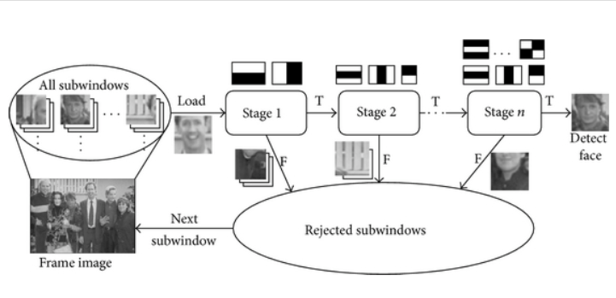Cascade structure for Haar classifiers.

**The Paul- Viola algorithm can be visualized as follows:**

  
source

**3.The Data Flow of the Proposed System**

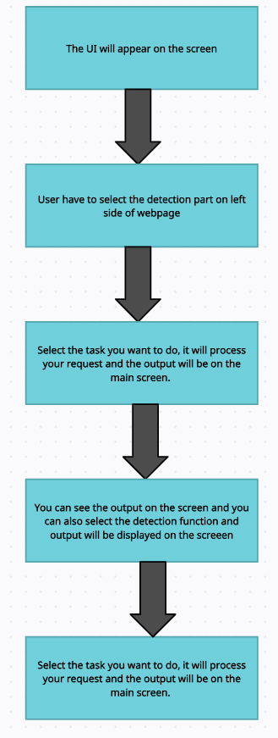

The data flow in this project is nothing but user input, whatever the user says, the application performs the task accordingly. The user input is nothing specific but the list of tasks which a user wants to get performed.

**4: Software Details**

The IDE used in this project is PyCharm. All the python files were created in PyCharm and all the necessary packages were easily installable in this IDE. For this project following modules and libraries were used i.e. Numpy,Pandas,OpenCV etc. I have created a live UI for interacting with the application using streamlitt as it gives a design and interesting look while interacting with the application.

4.1. PYCHARM

It is an IDE i.e. Integrated Development Environment which has many features like it supports scientific tools(like matplotlib, numpy, scipy etc) web frameworks (example Django,web2py and Flask) refactoring in Python, integrated python debugger, code completion, code and project navigation etc. It also provides Data Science when used with Anaconda.

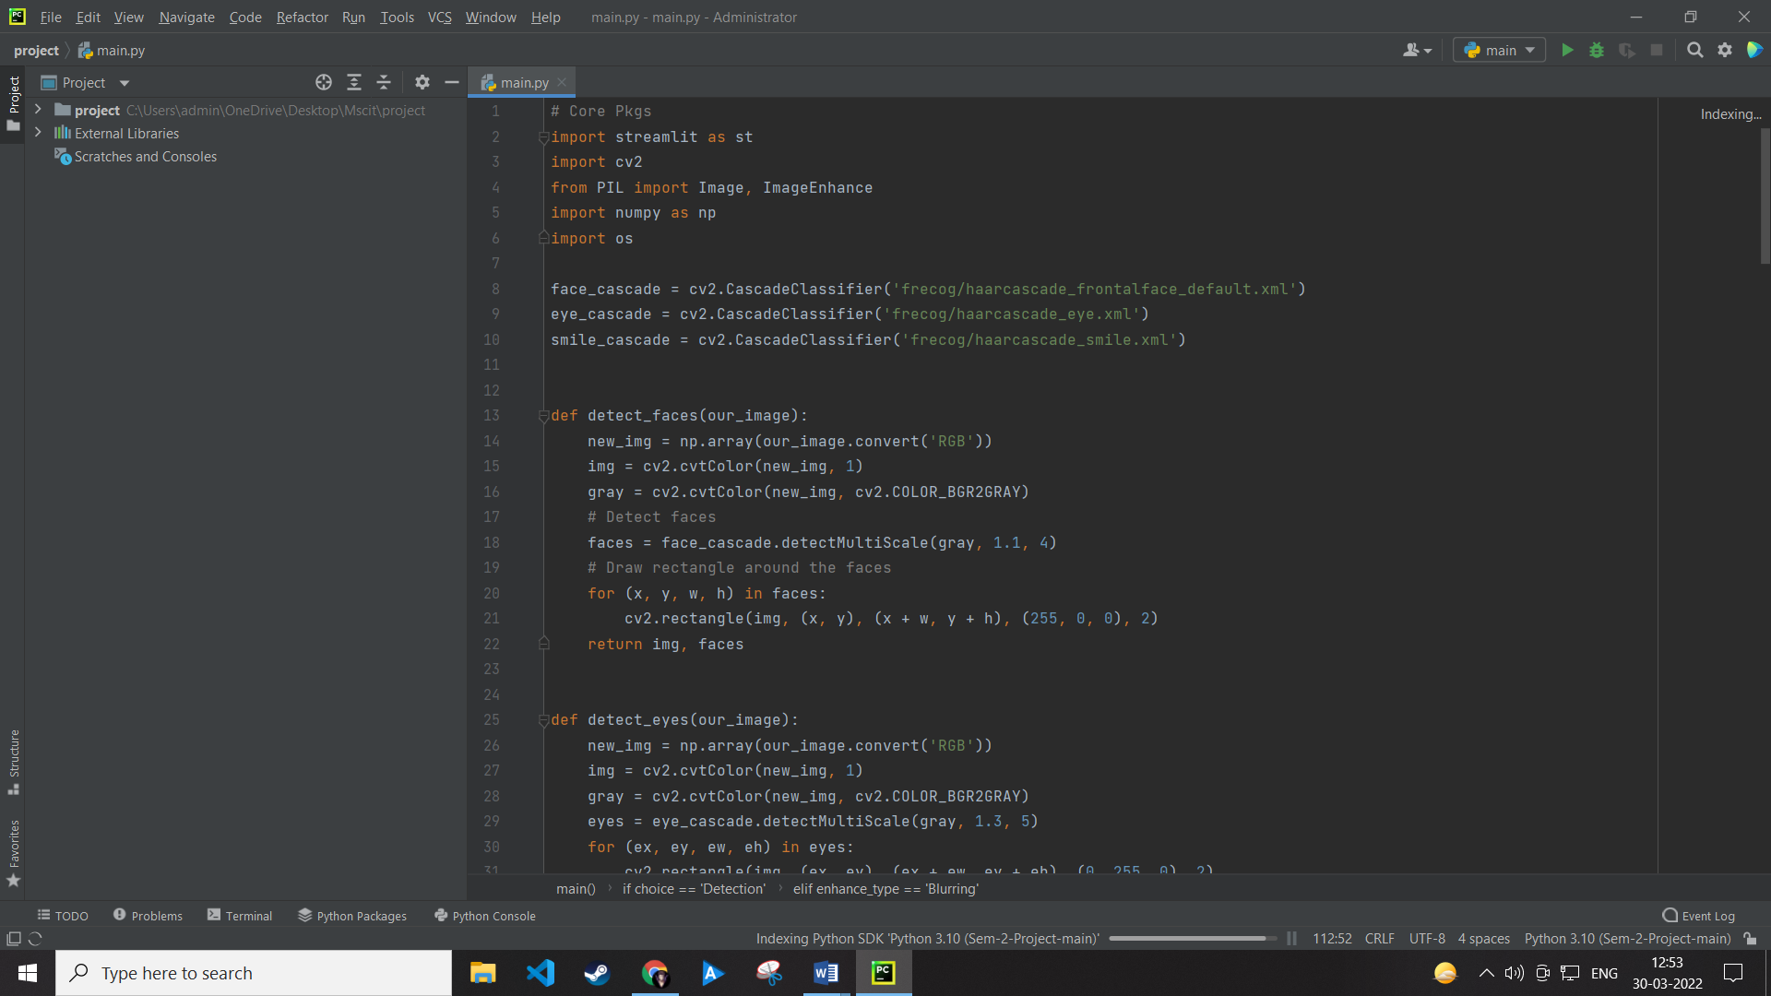

4.2. StreamLitt For UI

Streamlit is an open source app framework in Python language. It helps us create web apps for data science and machine learning in a short time. It is compatible with major Python libraries such as scikit-learn, Keras, PyTorch, SymPy(latex), NumPy, pandas, Matplotlib etc.



4.3. PYTHON LIBRARIES

In the above application following python libraries were used:

* Numpy :- NumPy is a library for the Python programming language, adding support for large, multi-dimensional arrays and matrices, along with a large collection of high-level mathematical functions to operate on these arrays.
* OpenCv:- OpenCV (Open Source Computer Vision Library) is an open source computer vision and machine learning software library.
* Streamlitt:- Streamlit is an open source app framework in Python language. It helps us create web apps for data science and machine learning in a short time.
* OS:- The OS module in Python provides functions for creating and removing a directory (folder), fetching its contents, changing and identifying the current directory, etc.

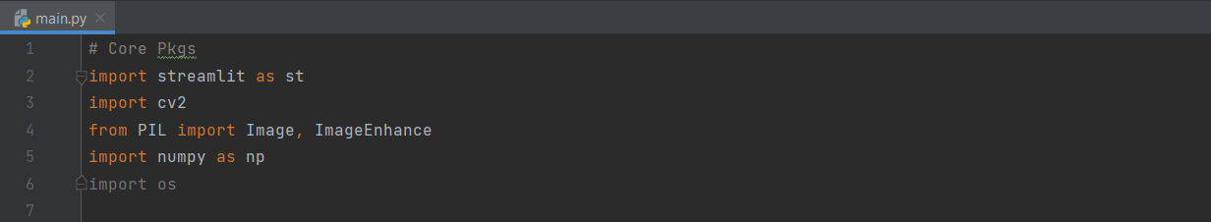

Imported Modules

**5. Implementation Work Details**

Face Detection app, is a web app that can perform many tasks of Image enhancing like making changes with brightness,contrast,blurringetc. This app is different from other traditional image enhancers in terms that it is not specific to desktop and user does not need to make account to use this.

5.1 DATA IMPLEMENTATION AND PROGRAM EXECUTION

As the first step, install all the necessary packages and libraries. The command used to install the libraries is “*pip install*” and then import it. The necessary packages included are as follows:

**5.1. LIBRARIES AND PACKAGES**

* Numpy :- NumPy is a library for the Python programming language, adding support for large, multi-dimensional arrays and matrices, along with a large collection of high-level mathematical functions to operate on these arrays.
* OpenCv:- OpenCV (Open Source Computer Vision Library) is an open source computer vision and machine learning software library.
* Streamlitt:- Streamlit is an open source app framework in Python language. It helps us create web apps for data science and machine learning in a short time.
* OS:- The OS module in Python provides functions for creating and removing a directory (folder), fetching its contents, changing and identifying the current directory, etc.

**5.2. FUNCTIONS**

**def detect_faces(our_image):** This function is used to detect the faces in an image which has been converted into an array the array is matched with harcas classifer and the ouput is displayed.

Files required for detecting faces:- haarcascade_frontalface_default.xml

**def detect_eyes(our_image):** This function is used to detect the eyes in an image which has been converted into an array the array is matched with harcas classifer and the ouput is displayed.

Files required for detecting faces:- haarcascade_eye.xml

**def detect_smiles(our_image):** This function is used to detect the smiles in an image which has been converted into an array the array is matched with harcas classifer and the ouput is displayed.

Files required for detecting faces:- haarcascade smile.xml

**def cartonize_image(our_image):**This function cartoonify your image by masking two layers and adding the one after another . This results in a cartoonified image.

**def cannize_image(our_image):**This function Cannonize our image and the edges are popped out of an image resulting in the borders and it is used to extract useful information.

**def main():**This function includes all the functionality of the web app .

**6.Source Code and Commands**

# Core Pkgs  
import streamlit as st  
import cv2  
from PIL import Image, ImageEnhance  
import numpy as np  
import os  
  
face_cascade = cv2.CascadeClassifier('frecog/haarcascade_frontalface_default.xml')  
eye_cascade = cv2.CascadeClassifier('frecog/haarcascade_eye.xml')  
smile_cascade = cv2.CascadeClassifier('frecog/haarcascade_smile.xml')  
  
  
def detect_faces(our_image):  
 new_img = np.array(our_image.convert('RGB'))  
 img = cv2.cvtColor(new_img, 1)  
 gray = cv2.cvtColor(new_img, cv2.COLOR_BGR2GRAY)  
 # Detect faces  
 faces = face_cascade.detectMultiScale(gray, 1.1, 4)  
 # Draw rectangle around the faces  
 for (x, y, w, h) in faces:  
 cv2.rectangle(img, (x, y), (x + w, y + h), (255, 0, 0), 2)  
 return img, faces  
  
  
def detect_eyes(our_image):  
 new_img = np.array(our_image.convert('RGB'))  
 img = cv2.cvtColor(new_img, 1)  
 gray = cv2.cvtColor(new_img, cv2.COLOR_BGR2GRAY)  
 eyes = eye_cascade.detectMultiScale(gray, 1.3, 5)  
 for (ex, ey, ew, eh) in eyes:  
 cv2.rectangle(img, (ex, ey), (ex + ew, ey + eh), (0, 255, 0), 2)  
 return img  
  
  
def detect_smiles(our_image):  
 new_img = np.array(our_image.convert('RGB'))  
 img = cv2.cvtColor(new_img, 1)  
 gray = cv2.cvtColor(new_img, cv2.COLOR_BGR2GRAY)  
 # Detect Smiles  
 smiles = smile_cascade.detectMultiScale(gray, 1.1, 4)  
 # Draw rectangle around the Smiles  
 for (x, y, w, h) in smiles:  
 cv2.rectangle(img, (x, y), (x + w, y + h), (255, 0, 0), 2)  
 return img  
  
  
def cartonize_image(our_image):  
 new_img = np.array(our_image.convert('RGB'))  
 img = cv2.cvtColor(new_img, 1)  
 gray = cv2.cvtColor(new_img, cv2.COLOR_BGR2GRAY)  
 # Edges  
 gray = cv2.medianBlur(gray, 5)  
 edges = cv2.adaptiveThreshold(gray, 255, cv2.ADAPTIVE_THRESH_MEAN_C, cv2.THRESH_BINARY, 9, 9)  
 # Color  
 color = cv2.bilateralFilter(img, 9, 300, 300)  
 # Cartoon  
 cartoon = cv2.bitwise_and(color, color, mask=edges)  
  
 return cartoon  
  
  
def cannize_image(our_image):  
 new_img = np.array(our_image.convert('RGB'))  
 img = cv2.cvtColor(new_img, 1)  
 img = cv2.GaussianBlur(img, (11, 11), 0)  
 canny = cv2.Canny(img, 100, 150)  
 return canny  
  
  
def main():  
 *"""Face Detection App"""* st.title("Face Detection App with addittional features")  
 st.text("Build with Streamlit and OpenCV by Manan Sharma")  
  
 activities = ["Detection", "About"]  
 choice = st.sidebar.selectbox("Select Activty", activities)  
  
 if choice == 'Detection':  
 st.subheader("Face Detection")  
  
 image_file = st.file_uploader("Upload Image", type=['jpg', 'png', 'jpeg'])  
  
 if image_file is not None:  
 our_image = Image.open(image_file)  
 st.text("Original Image")  
 # st.write(type(our_image))  
 st.image(our_image)  
  
 enhance_type = st.sidebar.radio("Enhance Type",  
 ["Original", "Gray-Scale", "Contrast", "Brightness", "Blurring"])  
 if enhance_type == 'Gray-Scale':  
 new_img = np.array(our_image.convert('RGB'))  
 img = cv2.cvtColor(new_img, 1)  
 gray = cv2.cvtColor(img, cv2.COLOR_BGR2GRAY)  
 # st.write(new_img)  
 st.image(gray)  
 elif enhance_type == 'Contrast':  
 c_rate = st.sidebar.slider("Contrast", 0.5, 3.5)  
 enhancer = ImageEnhance.Contrast(our_image)  
 img_output = enhancer.enhance(c_rate)  
 st.image(img_output)  
  
 elif enhance_type == 'Brightness':  
 c_rate = st.sidebar.slider("Brightness", 0.5, 3.5)  
 enhancer = ImageEnhance.Brightness(our_image)  
 img_output = enhancer.enhance(c_rate)  
 st.image(img_output)  
  
 elif enhance_type == 'Blurring':  
 new_img = np.array(our_image.convert('RGB'))  
 blur_rate = st.sidebar.slider("Blurring", 0.5, 3.5)  
 img = cv2.cvtColor(new_img, 1)  
 blur_img = cv2.GaussianBlur(img, (11, 11), blur_rate)  
 st.image(blur_img)  
  
 elif enhance_type == 'Original':  
 return None  
 else:  
 st.image(our_image, width=300)  
  
 # Face Detection  
 task = ["Faces", "Smiles", "Eyes", "Cannize", "Cartonize"]  
 feature_choice = st.sidebar.selectbox("Find Features", task)  
 if st.button("Process"):  
  
 if feature_choice == 'Faces':  
 result_img, result_faces = detect_faces(our_image)  
 st.image(result_img)  
  
 st.success("Found {} faces".format(len(result_faces)))  
 elif feature_choice == 'Smiles':  
 result_img = detect_smiles(our_image)  
 st.image(result_img)  
  
  
 elif feature_choice == 'Eyes':  
 result_img = detect_eyes(our_image)  
 st.image(result_img)  
  
 elif feature_choice == 'Cartonize':  
 result_img = cartonize_image(our_image)  
 st.image(result_img)  
  
 elif feature_choice == 'Cannize':  
 result_canny = cannize_image(our_image)  
 st.image(result_canny)  
  
  
  
  
 elif choice == 'About':  
 st.subheader("About Face Detection App")  
 st.markdown("Built with Streamlit by Manan Sharma")  
  
 st.success("Sem 2 Project")  
  
  
if __name__ == '__main__':  
 main()

**7. Input/Output Screenshot**

*1)Image Input*

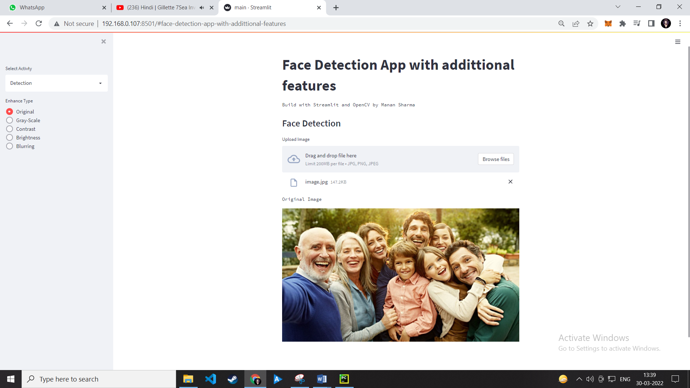

Input of image and output as shownn

*2)Grayscale Filter*

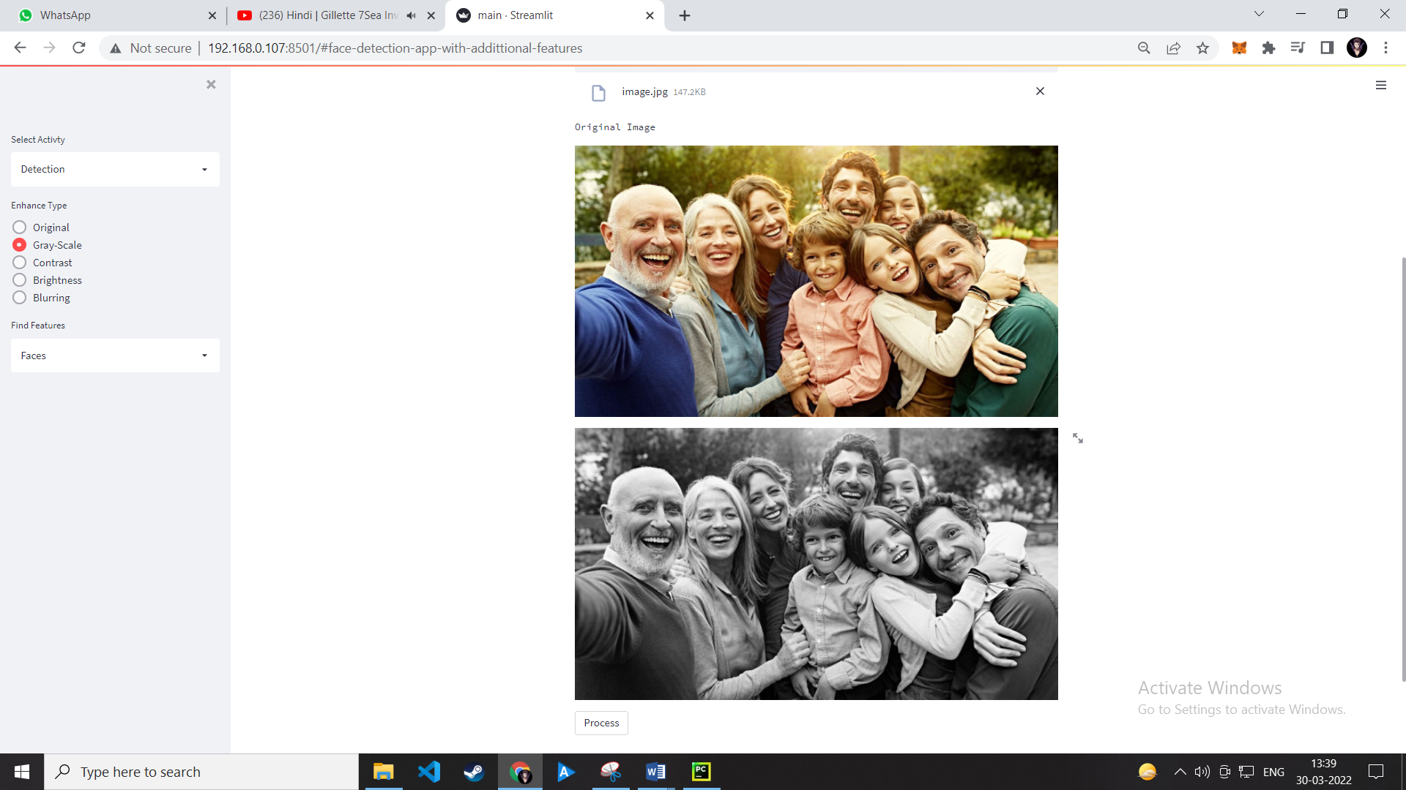GrayScale Image

*3) Contrast Filter*

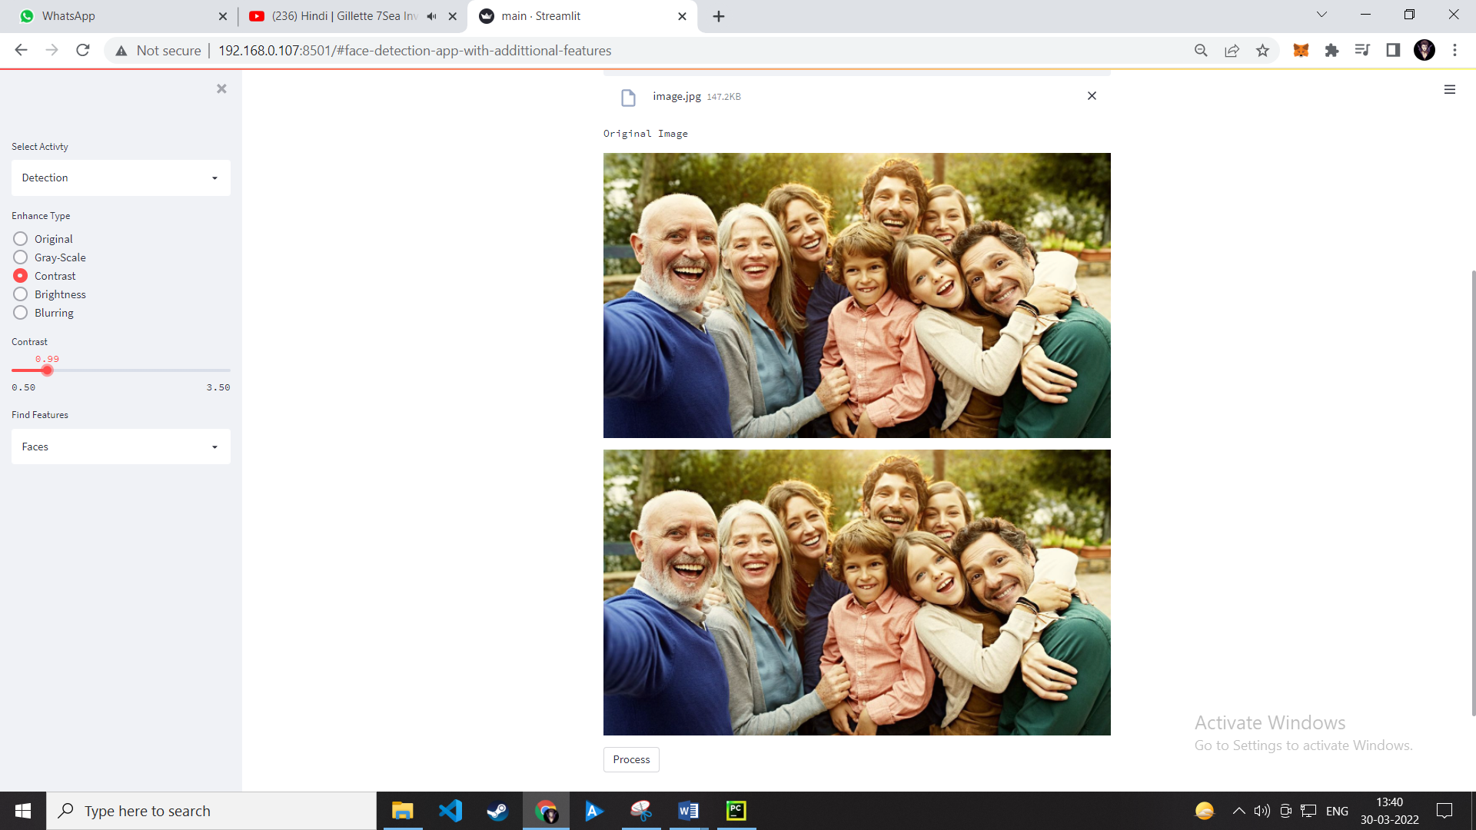

Before applying contrast filter

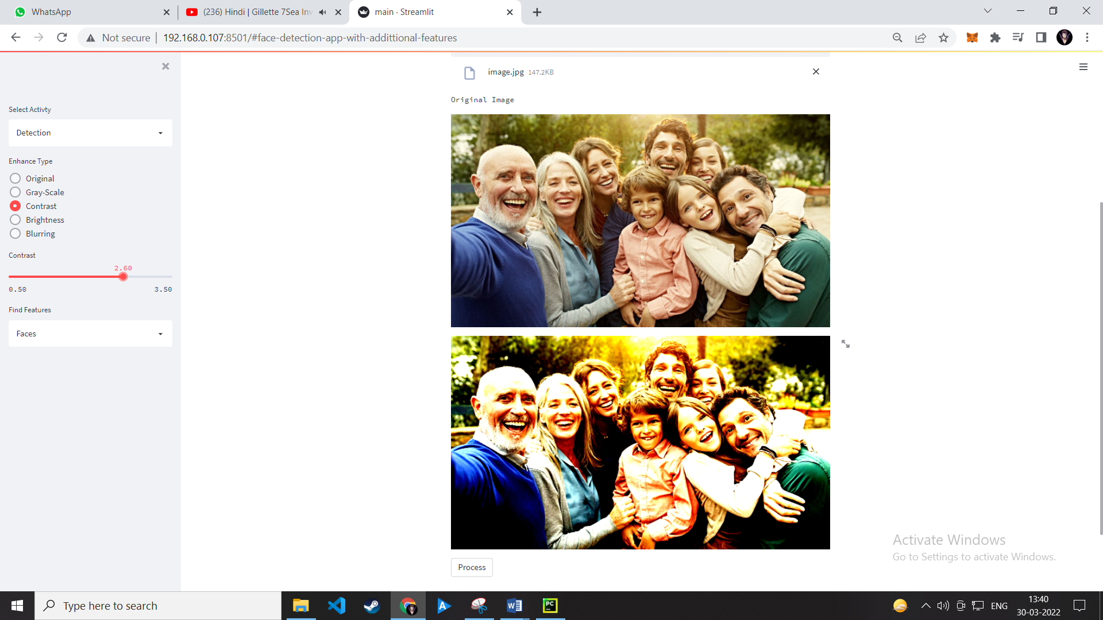After applying contrast filter

*4)Brightness Filter*

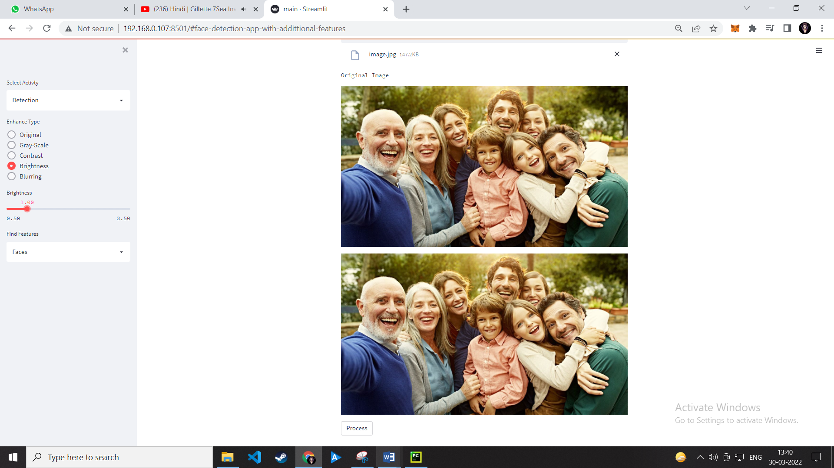Before applying Brightness filter

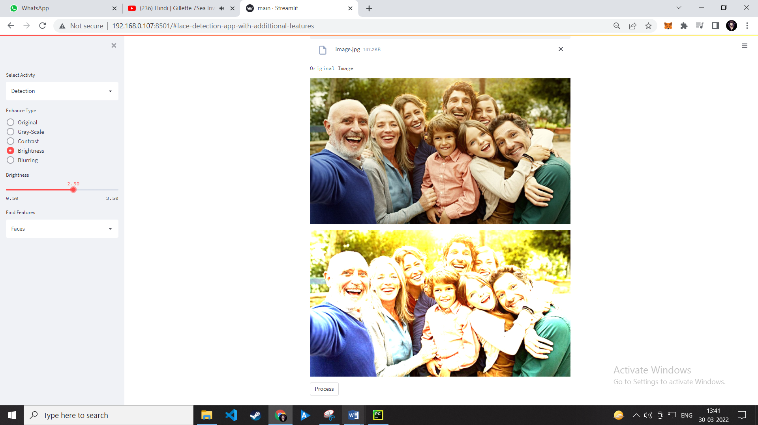After applying Brightness Filter

*5)Blurring Filter*

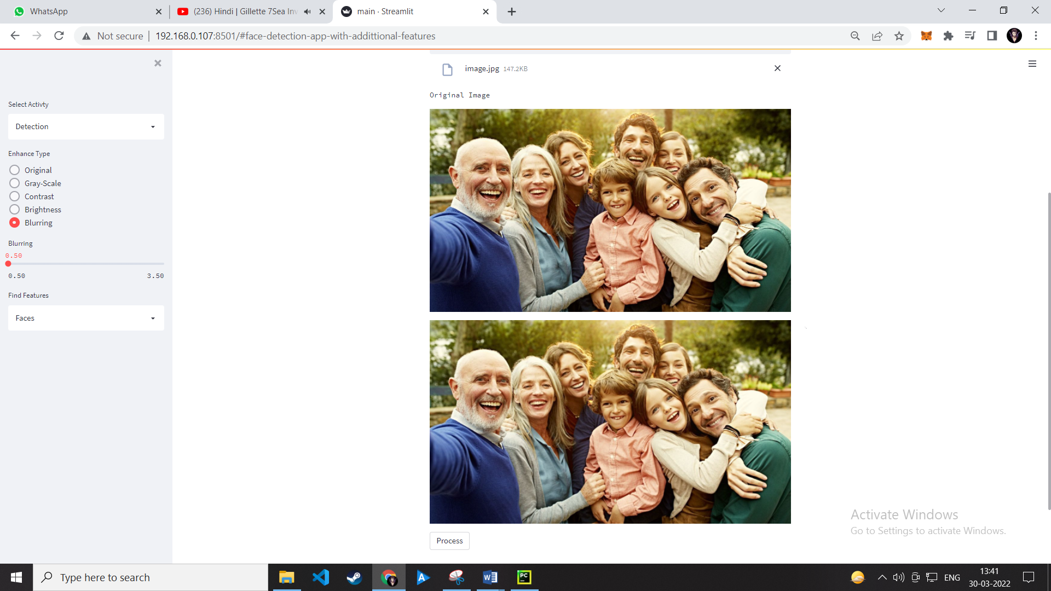

Before Applying Blurring Filter

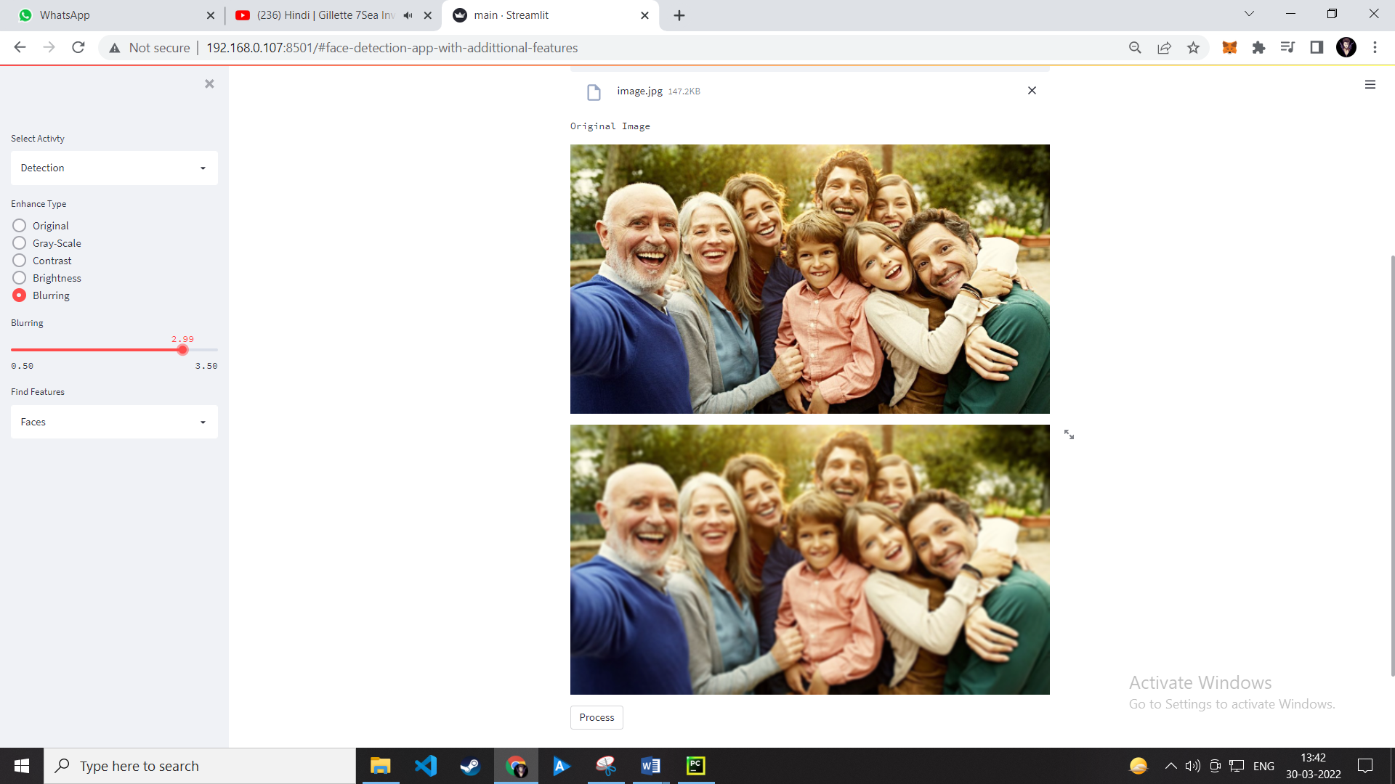After Applying Blurring filter

*6)Face Detection*

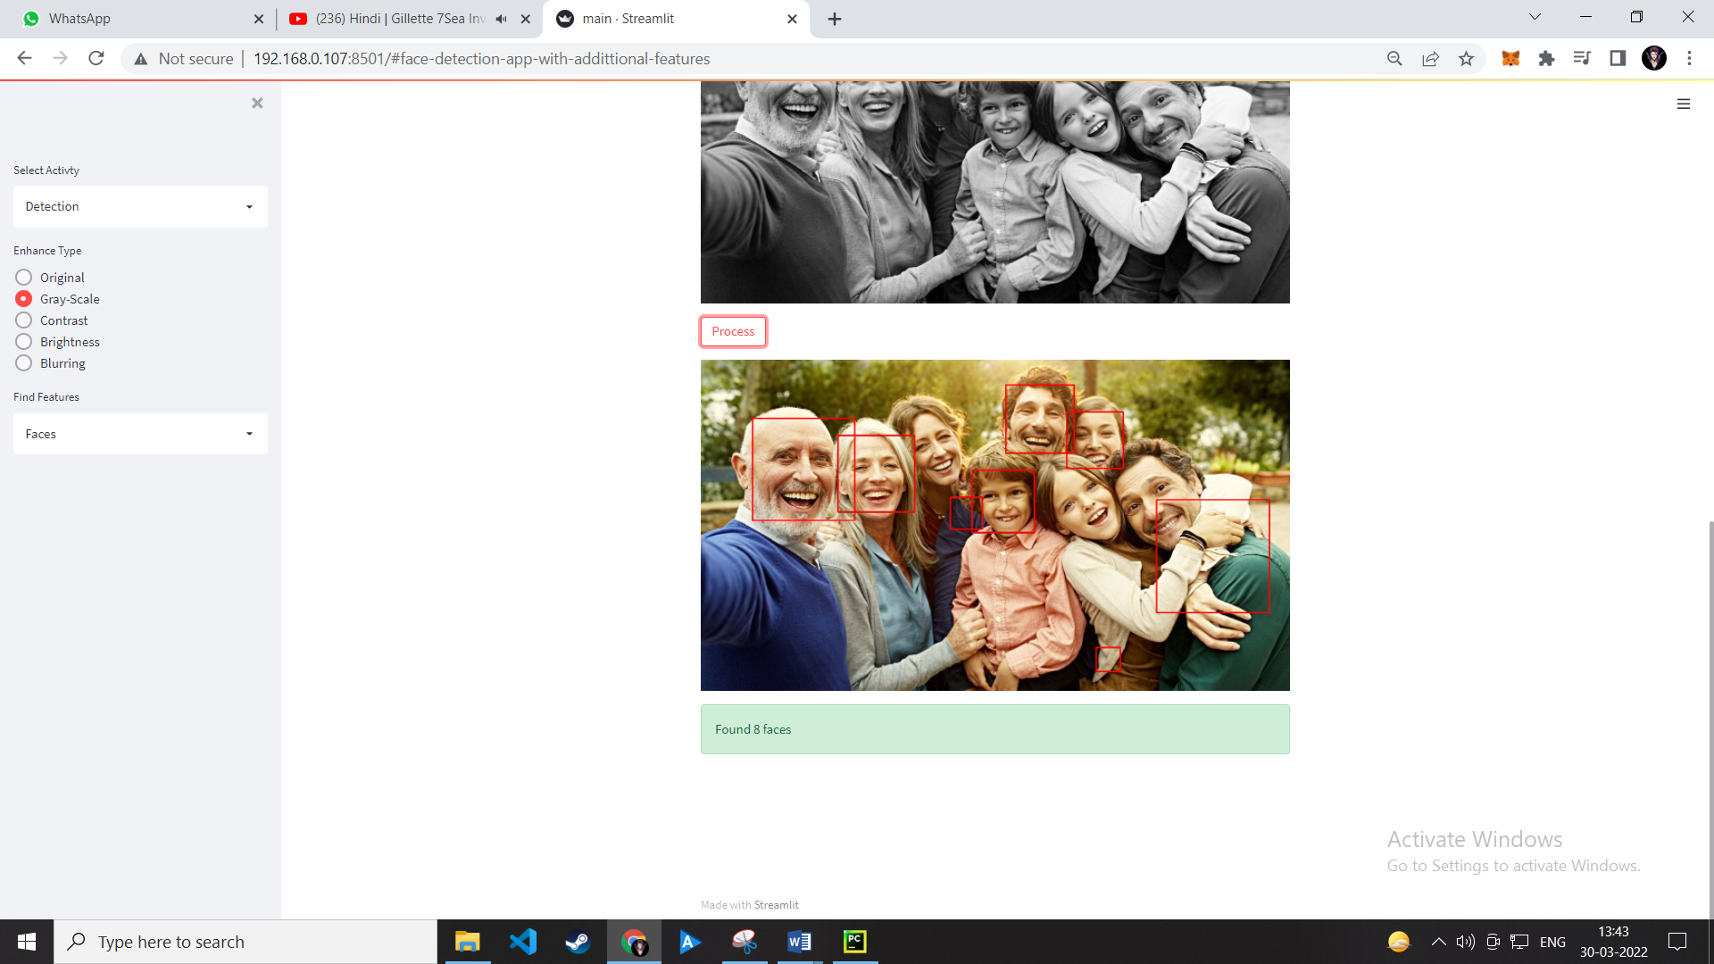

After applying face detection Filter

*7)Eye Detection*

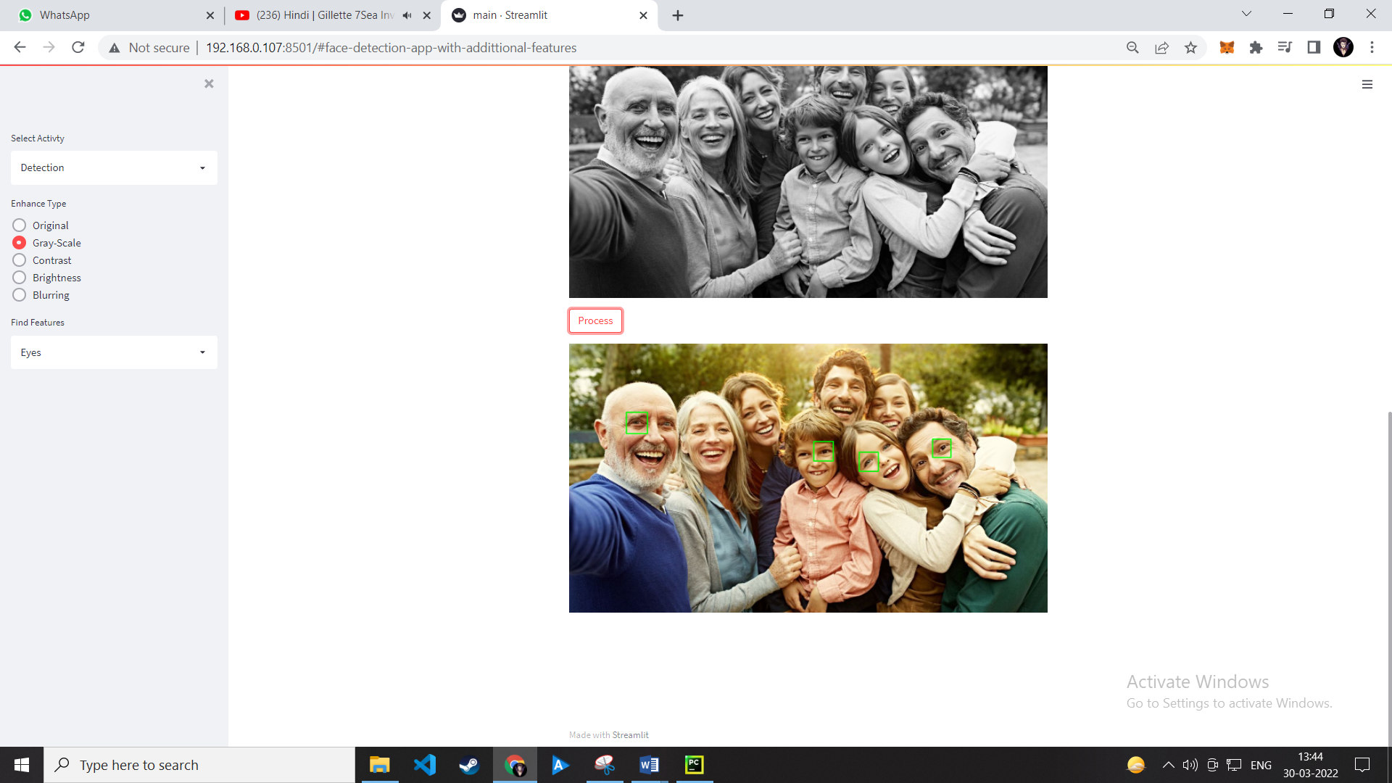After Applying eye detection filter

*8)Cannizing Image*

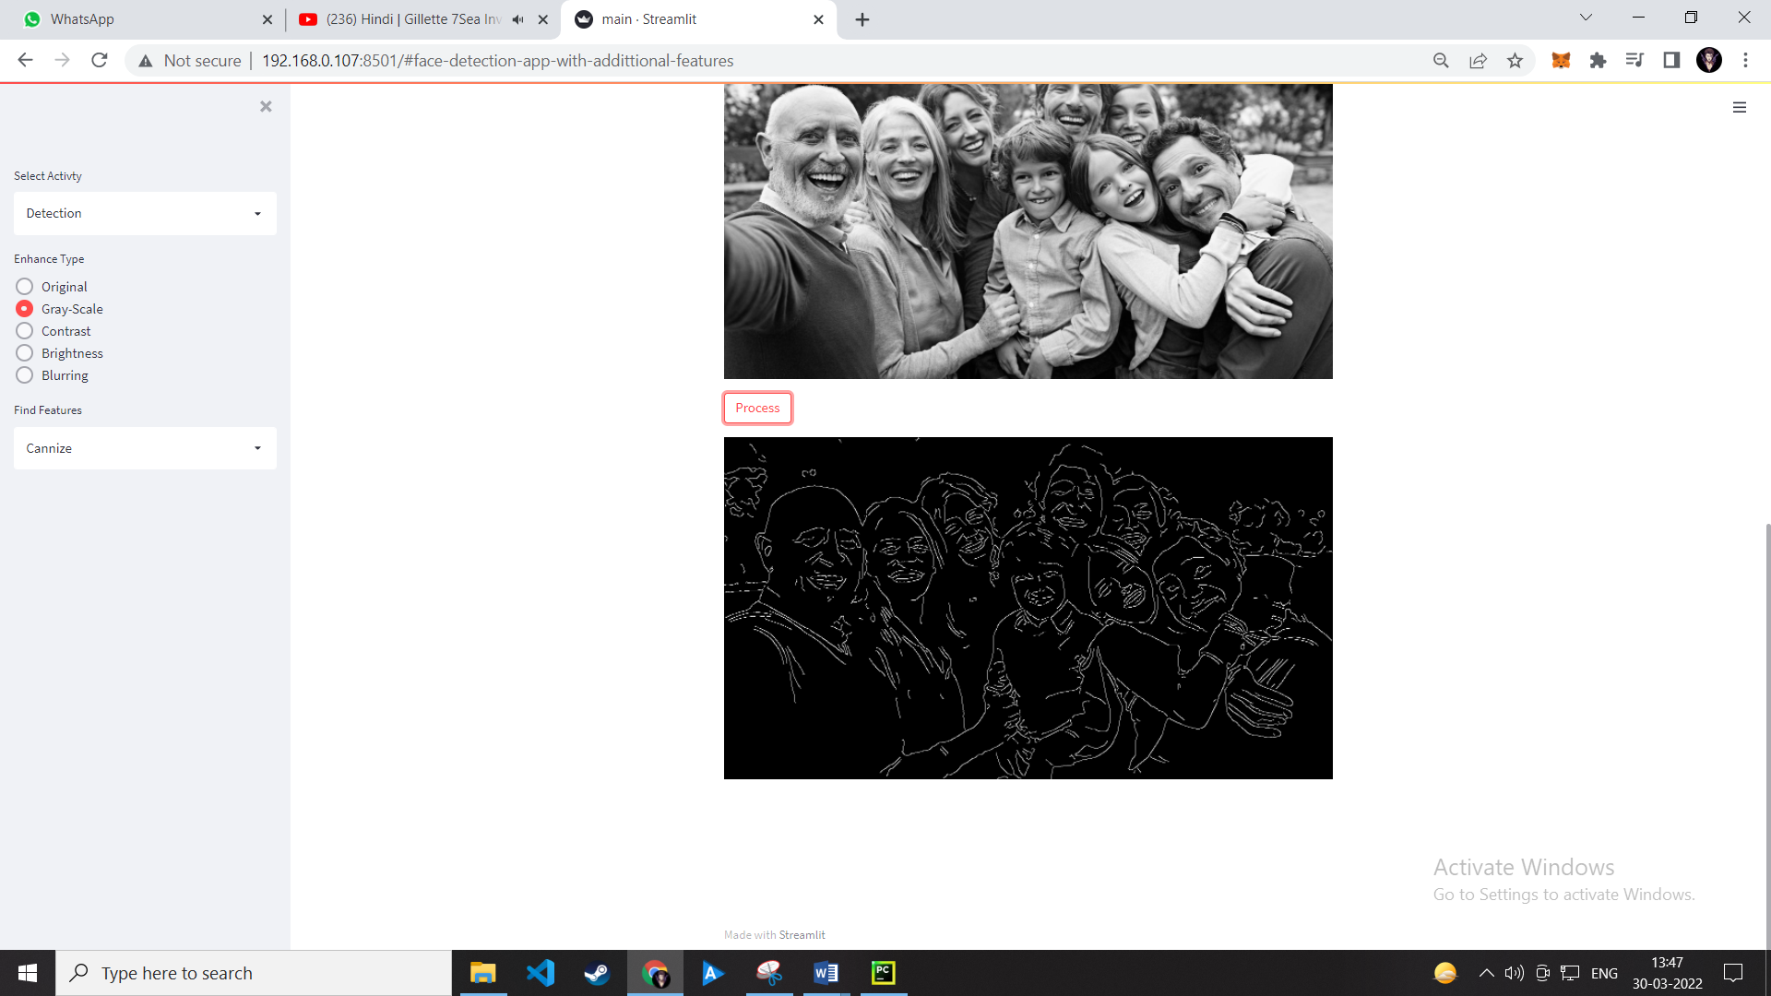After Cannize the image..

*9)Cartoonizing the image*

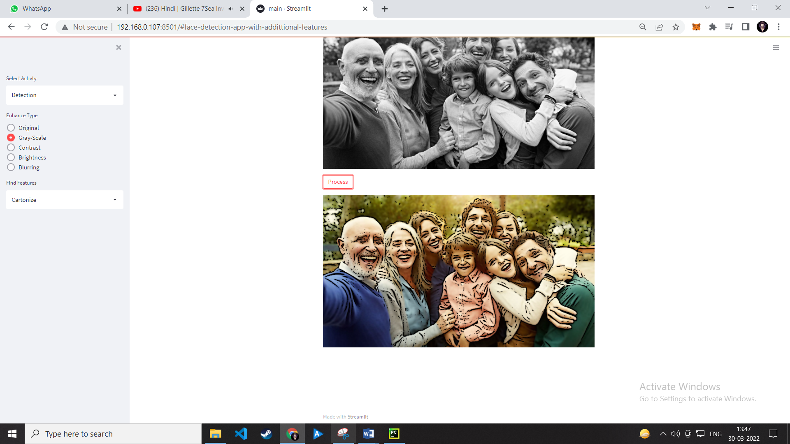

After Cartoonizing the image

*10)The About Page*

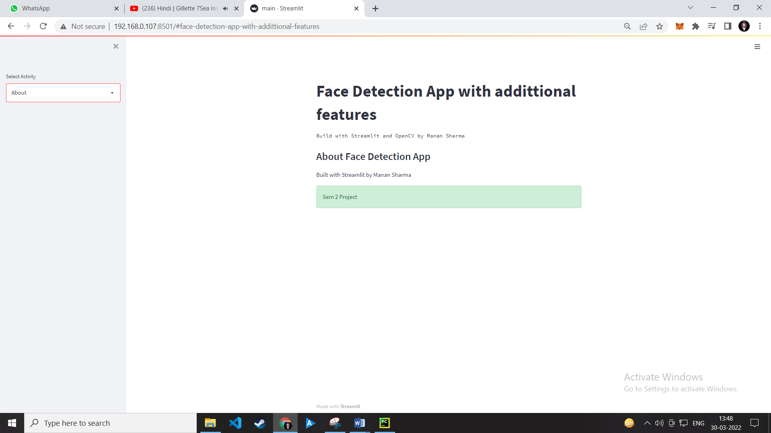

**8.Conclusion**

The web app is a very helpful image enhancement app without any doubt as it saves time of the user by not downloading an extensive software, its effectiveness and efficiency. But while working on this project, there were some limitations encountered and also realized some scope of enhancement in the future which are mentioned below:

8.1. LIMITATIONS

* The enhanced image to be saved is a problem
* While the Has classifier algorithm works but it is not efficient as it is very faulty.
* The app is not at all efficient it takes time to load and process big images.
* A large number of things can be added to make this app more efficient useful and usable.

9.2. SCOPE FOR FUTURE WORK

* Make a database for saving the enhanced photos
* Use different algorithms to detect various features so it detect the features efficiently and with less error.
* Add more functionalities

Thank you!